***Objectives* -:**

* Understanding the relationships between accelerated motion for an electron and the field strength and direction.
* Wiggle the transmitter electron manually or have it oscillate automatically.
* When the radiation reaches the antenna to the right, what happens to the electron?
* How does the amplitude of oscillation of the receiving electron compare to the amplitude of the source electron?
* If you increase the frequency of oscillation, how does the amplitude of the source signal change?
* How does the amplitude of the radiation change as the signal travels to the right?
* How does the frequency of the electron in the receiving antenna compare to the frequency of the electron in the source antenna (you can use a stopwatch to count the period)?
* To study the variation of intensity with incident angle, relative refractive index of both the medium and frequency.
* To study the variation of speed of light wave with frequency relative refractive index of two medium, incident angle.
* To see how the phase changes in the cases of reflected and refracted waves from the incident wave.
* To prove the total internal reflection and calculate the critical angle.

***Theory* -:** Radio waves are a type of electromagnetic (EM) radiation with wavelengths in the electromagnetic spectrum longer than infrared light.

* The lowest frequency portion of the electromagnetic spectrum is designated as “radio,” generally considered to have wavelengths within 1 millimeter to 100 kilometers or frequencies within 300 GHz to 3 kHz.
* Like all other electromagnetic waves, radio waves travel at the speed of light.
* Artificially generated radio waves are used for fixed and mobile radio communication, broadcasting, radar and other navigation systems, communications satellites, computer networks and innumerable other applications.
* Different frequencies of radio waves have different propagation characteristics in the Earth’s atmosphere—long waves may cover a part of the Earth very consistently, shorter waves can reflect off the ionosphere and travel around the world, and much shorter wavelengths bend or reflect very little and travel on a line of sight.

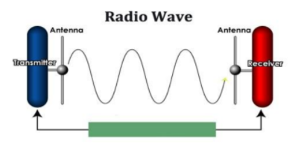

* In radio communications, a [transmitting antenna](https://www.sciencedirect.com/topics/computer-science/transmitting-antenna) is used to launch an [electromagnetic signal](https://www.sciencedirect.com/topics/computer-science/electromagnetic-signal) into space, which is received by a second antenna at a remote location. For antennas located in free space, such as for communication between satellites, the propagation effects consist simply of the reduction of the signal with distance as a result of spreading the transmitted energy over an area that increases with distance. When one or both ends of the communication link are located near the ground, the atmosphere, terrain variation, vegetation, and buildings influence the received signal. Besides the dependence on the separation between transmitter and receiver, these features effect signal characteristics such as spatial and temporal fading, frequency dependence, and echo-induced time delay spread.
* The [conductivity](https://www.sciencedirect.com/topics/materials-science/conductivity) and dielectric constant of the ground vary considerably from those of the atmosphere. At very-low frequencies, ground waves may be satisfactorily propagated for distances of several thousand kilometers. At high frequencies, however, the losses are so great that signals can be propagated for only a few hundred kilometers by ground wave. Propagation in the medium- and high-frequency bands is chiefly by ground wave and by reflection from the [ionosphere](https://www.sciencedirect.com/topics/physics-and-astronomy/ionosphere), and severe fading is caused in these frequency bands by the interference between ground and ionospheric waves.

***ELECTROMAGNETIC FIELDS***

An electromagnetic field (also EM field) is a classical (i.e. non-quantum) [field](https://en.wikipedia.org/wiki/Field_(physics)) produced by accelerating [electric charges](https://en.wikipedia.org/wiki/Electric_charge). The electromagnetic field propagates at the speed of light (in fact, this field can be identified as light) and interacts with charges and currents.

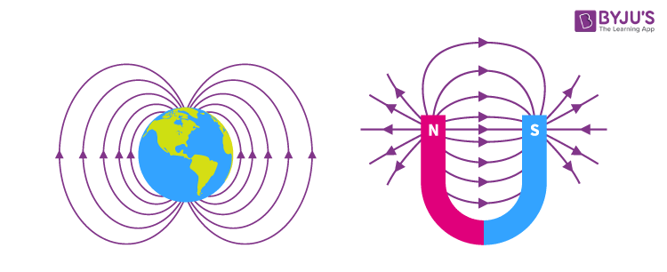

The field can be viewed as the combination of an [electric field](https://en.wikipedia.org/wiki/Electric_field) and a [magnetic field](https://en.wikipedia.org/wiki/Magnetic_field). The electric field is produced by stationary charges, and the magnetic field by moving charges (currents); these two are often described as the sources of the field. The way in which charges and currents interact with the electromagnetic field is described by [Maxwell's equations](https://en.wikipedia.org/wiki/Maxwell%27s_equations) and the [Lorentz force law](https://en.wikipedia.org/wiki/Lorentz_force_law). The force created by the electric field is much stronger than the force created by the magnetic field. Lorentz Force Law and [Maxwell’s Equation](https://byjus.com/physics/maxwells-equations/) explains how the interaction between currents and charges occurs with the electromagnetic field.

[Electromagnetic fields](https://ec.europa.eu/health/scientific_committees/opinions_layman/en/electromagnetic-fields/glossary/def/electromagnetic-field-EMF.htm) are a combination of invisible electric and [magnetic fields](https://ec.europa.eu/health/scientific_committees/opinions_layman/en/electromagnetic-fields/glossary/mno/magnetic-field.htm) of force. They are generated by natural phenomena like the [Earth’s magnetic field](https://ec.europa.eu/health/scientific_committees/opinions_layman/en/electromagnetic-fields/glossary/ghi/geomagnetic-field.htm) but also by human activities, mainly through the use of electricity.

***REFLECTION AND REFRACTION***

***Reflection:***

**Reflection**occurs when light traveling through one material bounces off a different material. The reflected light still travels in a straight line, only in a different direction. The light is reflected at the same angle that it hits the surface. The **angle of incidence** is equal to the **angle of reflection.** The angle of incidence is the angle between the incoming light and a line perpendicular to the surface called the **normal**. The angle of reflection is the angle between the reflected light and the normal. The symbol Ɵ means “angle'' and arrows represent **rays**of light.

***Refraction:***

When light traveling through one material reaches a second material, some of the light will be reflected, and some of the light will enter the second material. At the point at which the light enters the second material, the light will bend and travel in a different direction than the incident light. This is called refraction. Refraction happens because the speed of light is different in different materials (though always less than the speed of light in a vacuum).

***Refractive Index:***

The refractive index of a medium is defined as the ratio of the speed of light in vacuum to the speed of light in medium.

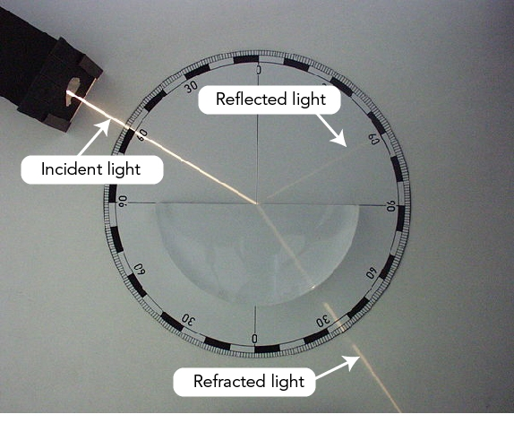

***Snell's Law***

Snell's law relates the sines of the angles of incidence and transmission to the index of refraction for each material:

$$\frac{\sin{ϴ_{1}}}{\sin{ϴ_{2}}}=\frac{n_{2}}{n_{1}}$$

It should be noted that the angles are measured from the normal line at the interface

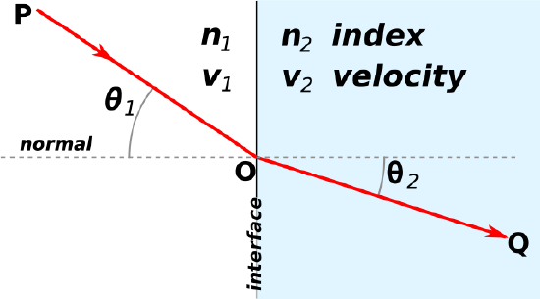

Additionally, because the index of refraction is related to the speed of light in the material, the following equation is also true: $$\frac{\sin{ϴ_{1}}}{\sin{ϴ_{2}}}=\frac{v_{1}}{v_{2}}$$

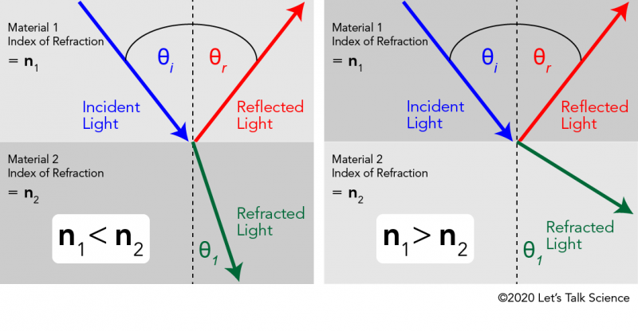

***TOTAL INTERNAL REFLECTION:***

The critical angle is the angle of incidence above which total internal reflection occurs. The angle of incidence is measured with respect to the normal at the refractive boundary (see diagram illustrating Snell’s law). Consider a light ray passing from glass into air. The light emanating from the interface is bent towards the glass. When the incident angle is increased sufficiently, the transmitted angle (in air) reaches 90 degrees. It is at this point no light is transmitted into air. The critical angle $θ_{c}$  is given by Snell’s law, $n_{1}\sin{θ_{1}}= n_{21n }\sin{θ_{2}}$ . Here, $n_{1}$ and $n_{2}$ are refractive indices of the media, and $θ_{1 }$ and $θ_{2}$  are angles of incidence and refraction, respectively. To find the critical angle, we find the value for $θ_{1 }$ when $θ_{2 }$ = 90° and thus $\sin{θ_{2}}$ =1. The resulting value of $θ_{1 }$ is equal to the critical angle $θ_{c }$ = $θ_{1 }$ = $\sin^{-1}{\frac{n_{2}}{n_{1}}}$. So, the critical angle is only defined when $\frac{n_{2}}{n_{1}}$ is less than 1.

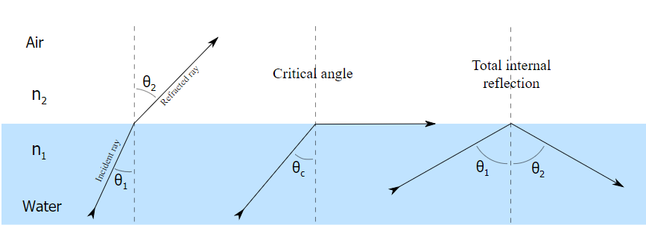

***Phase change:***

Reflected light will experience a 180 degree phase change when it reflects from a medium of higher [index of refraction](http://hyperphysics.phy-astr.gsu.edu/hbase/geoopt/refr.html#c2) and no phase change when it reflects from a medium of smaller index. Note below that the reflection when traveling from air at n=1 to oil at n = 1.4 experiences the phase change, but from oil to water at n = 1.33 there is no phase change.

***Observations and conclusions* -:**

***Simulation 1*** -:

1. Understanding the relationships between accelerated motion for an electron and the field strength and direction.

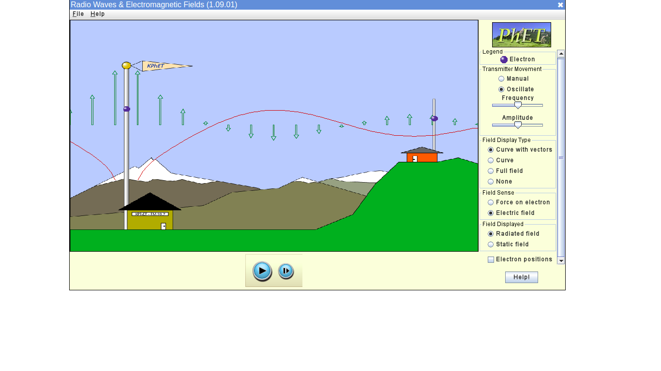

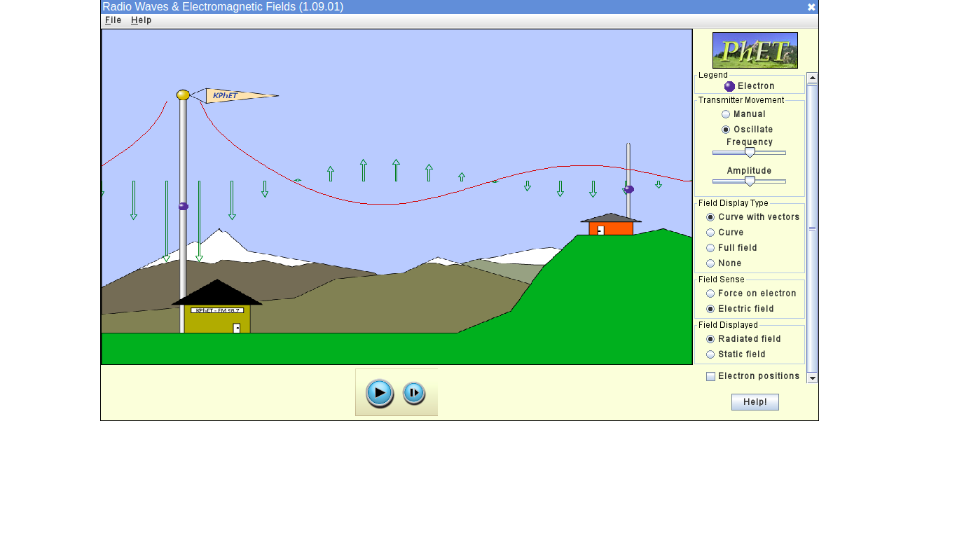

**Conclusion:**

* Strength: Larger the acceleration of the transmitting electron stronger the electromagnetic field strength, that is, larger force vectors.
* Direction: It takes some time for the change in this direction of the force to be felt since this change is communicated or propagated out at the speed of light. First the force will be exerted strongly in one direction then this will reverse and the electron will feel a strong force in the opposite direction, and the cycle will continue. The direction of arrows move with direction of electron and both electrons (source and receiver) are moving in same direction.

1. 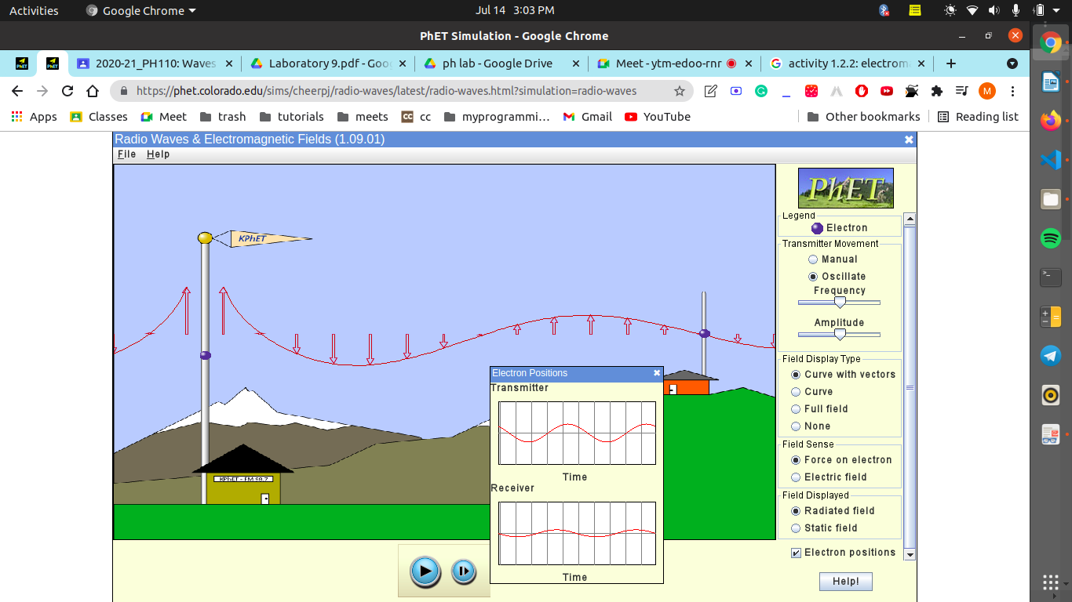When the radiation reaches the antenna to the right, what happens to the electron?

**Conclusion:**

It is evident from this snapshot that when the radiation reaches the antenna on the right, the net force on the receiving electron is zero, and it then moves in the direction of the force, i.e. if the force is directed downwards, the electron will travel downwards as well. Finally, until the electromagnetic waves with the new frequency come, the receiving electron will continue to oscillate at its old frequency.

1. How does the amplitude of oscillation of the receiving electron compare to the amplitude of the source electron?

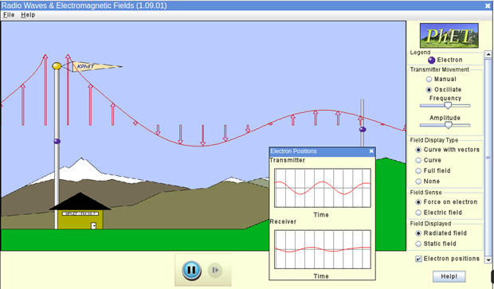

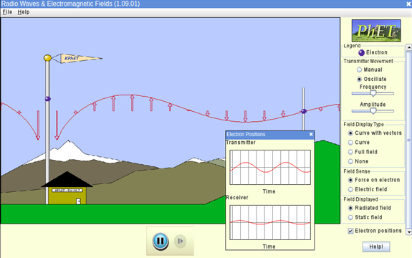

**Conclusion:**

If no other parameters are changed, the amplitude of both electrons oscillations remains constant throughout the experiment. However, due to various sorts of channel distortions, the amplitude of the receiving electron oscillation is smaller than that of the source electron, making the signal weak.

1. If you increase the frequency of oscillation, how does the amplitude of the source signal change?
2. Original Frequency:

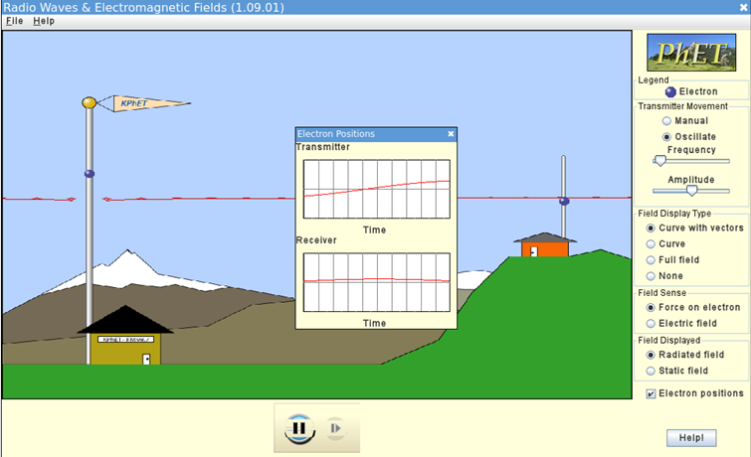

1. After Changing Frequency:

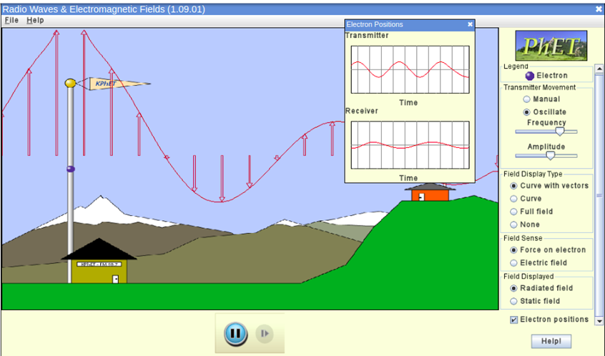

**Conclusion:**

We can see from the snapshots that there is no change in the amplitude though the wavelength has changed a lot which is expected because :- c= λf.

1. How does the amplitude of the radiation change as the signal travels to the right?

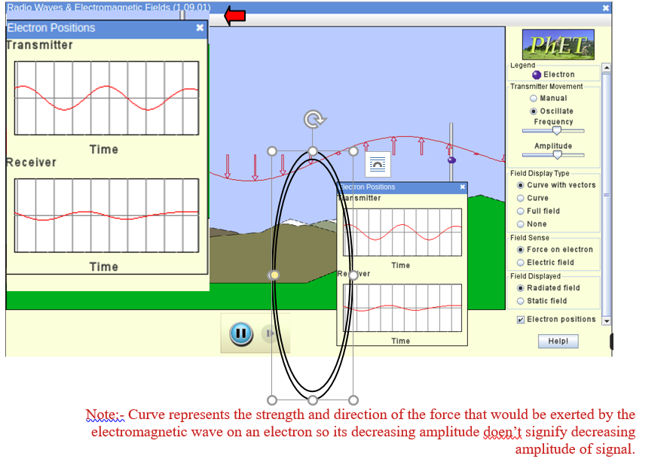

**Conclusion:**

As the signal goes to the right and receiver, the amplitude decreases, and we can deduce from the snapshot that the ultimate amplitude is lower than the one created from the source. The reason of decreasing amplitude is various types of distortion that occurs in the channel.

1. 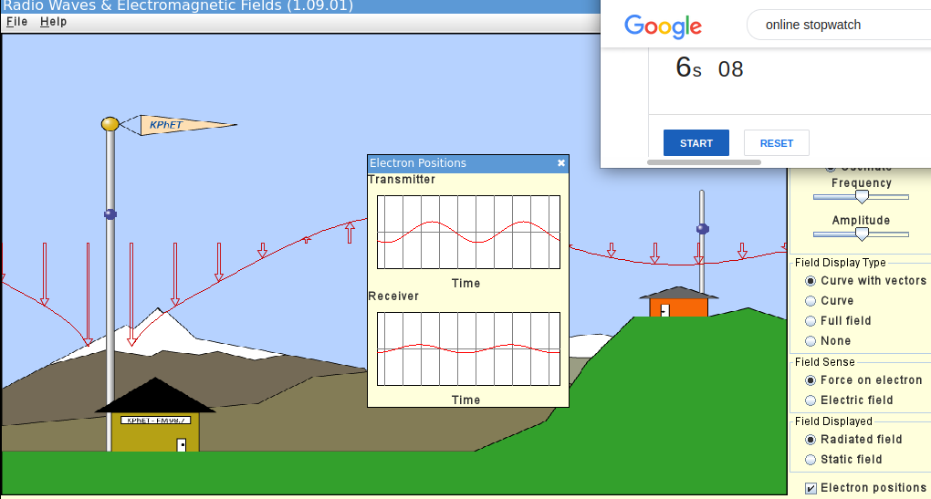How does the frequency of the electron in the receiving antenna compare to the frequency of the electron in the source antenna.

**Conclusion:**

Logical: The electron in the receiving antenna feels only the force resulting from the electromagnetic wave at its current location. It only "sees" the transmitting electron because of the effects that the transmitting electron has on the electromagnetic waves. **So the receiving electron will keep oscillating at its original frequency until the electromagnetic waves with the new frequency arrive.** (they move towards the receiving antenna at the speed of light).

From observations: both wave forms took 6.08 seconds to complete one cycle.

**SIMULATION 2:**

***OBSERVING CHANGE IN INTENSITY BY***

* CHANGING REFRACTIVE INDEX OF MEDIUM 2

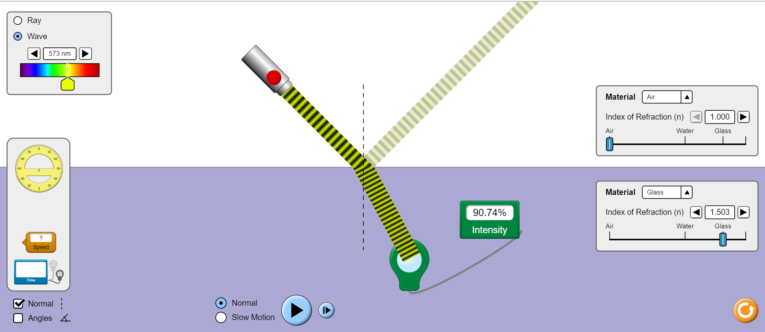

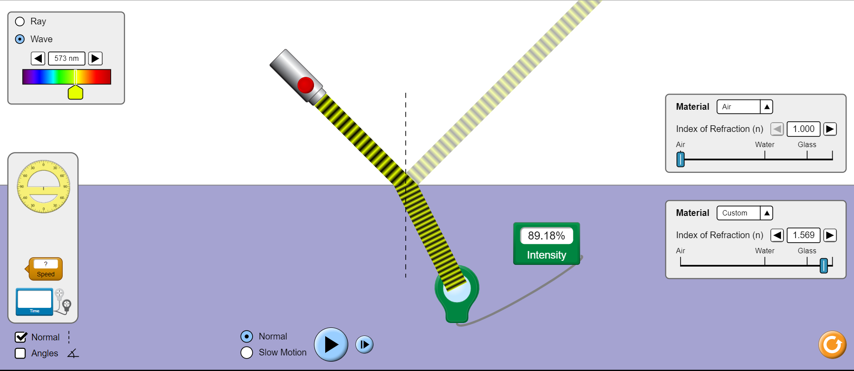

**Conclusion:**

On increasing the relative refractive index ,i.e., refractive index of medium 2,the intensity of refracted ray decreases.

* CHANGING ANGLE OF INCIDENCE

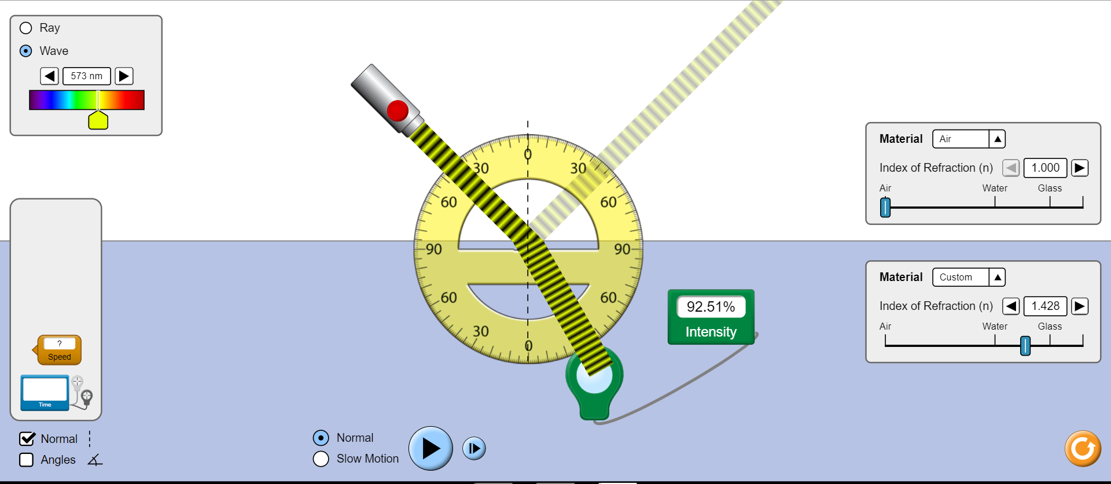

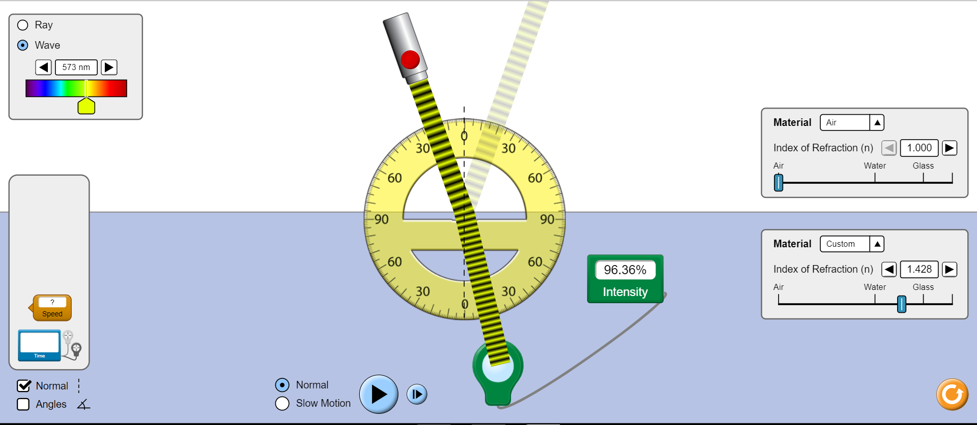

**Conclusion:**

On decreasing the angle of incidence, the intensity of refracted ray increases.

* CHANGING FREQUENCY

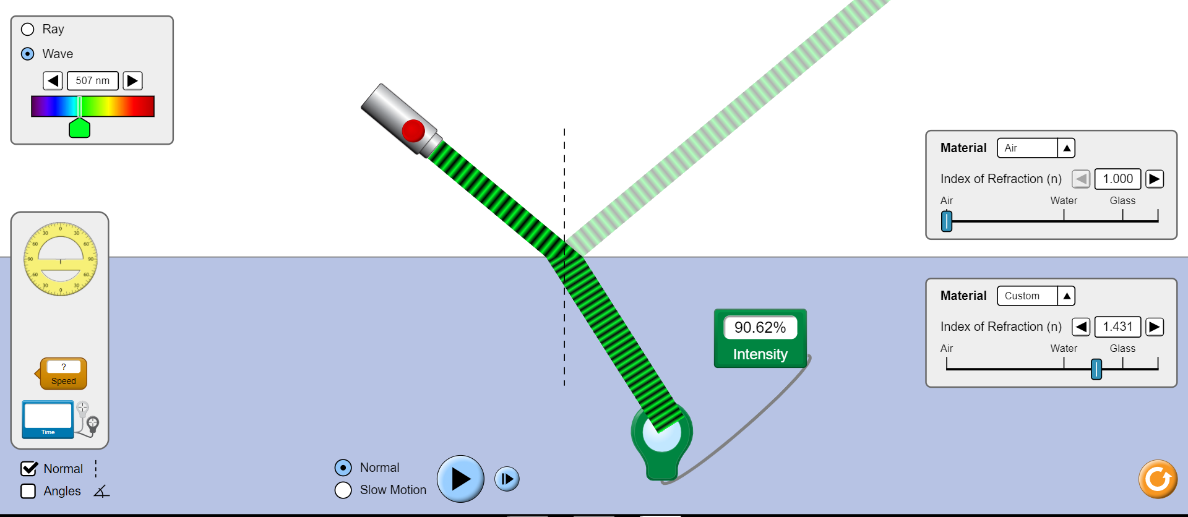

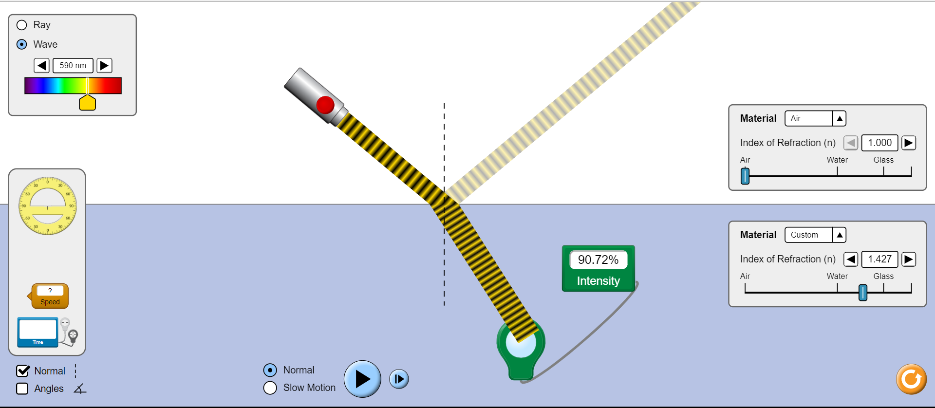

**Conclusion:**

The intensity of refracted ray in independent of frequency of incident light wave.

***OBSERVING CHANGE IN VELOCITY BY***

The wave is initially moving with the speed of light, i.e., c.

* CHANGING FREQUENCY

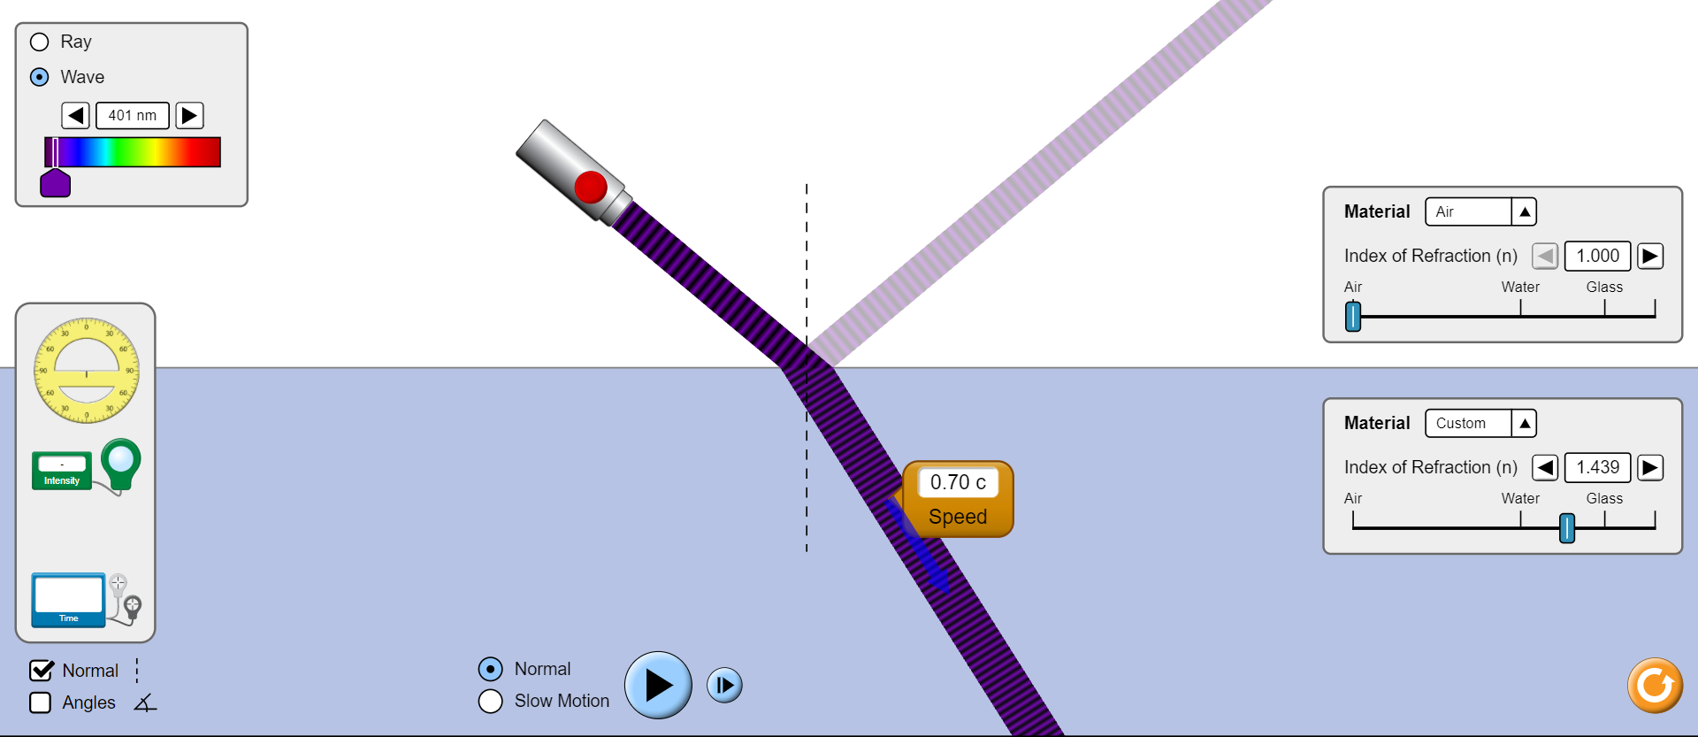

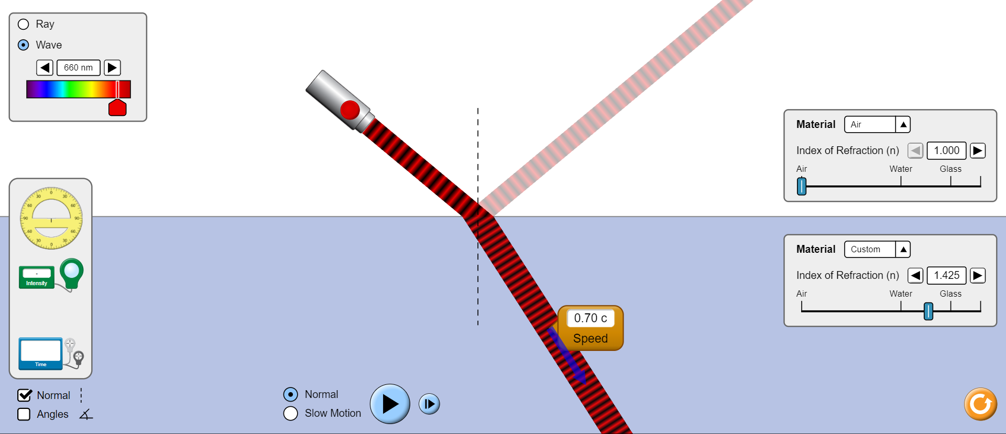

**Conclusion:**

The speed of refracted wave is independent of frequency of incident wave.

* BY CHANGING THE RELATIVE REFRACTIVE INDEX

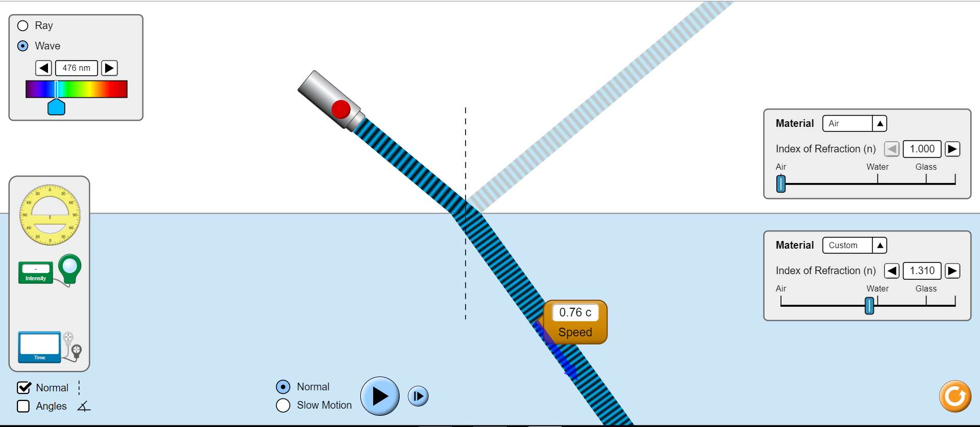

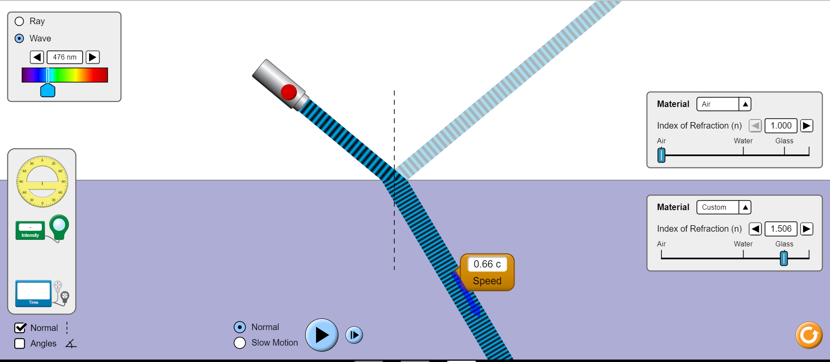

**Conclusion:**

On increasing the relative refractive index, i.e., the refractive index of medium 2, the speed of refracted ray decreases.

* BY CHANGING ANGLE OF INCIDENCE

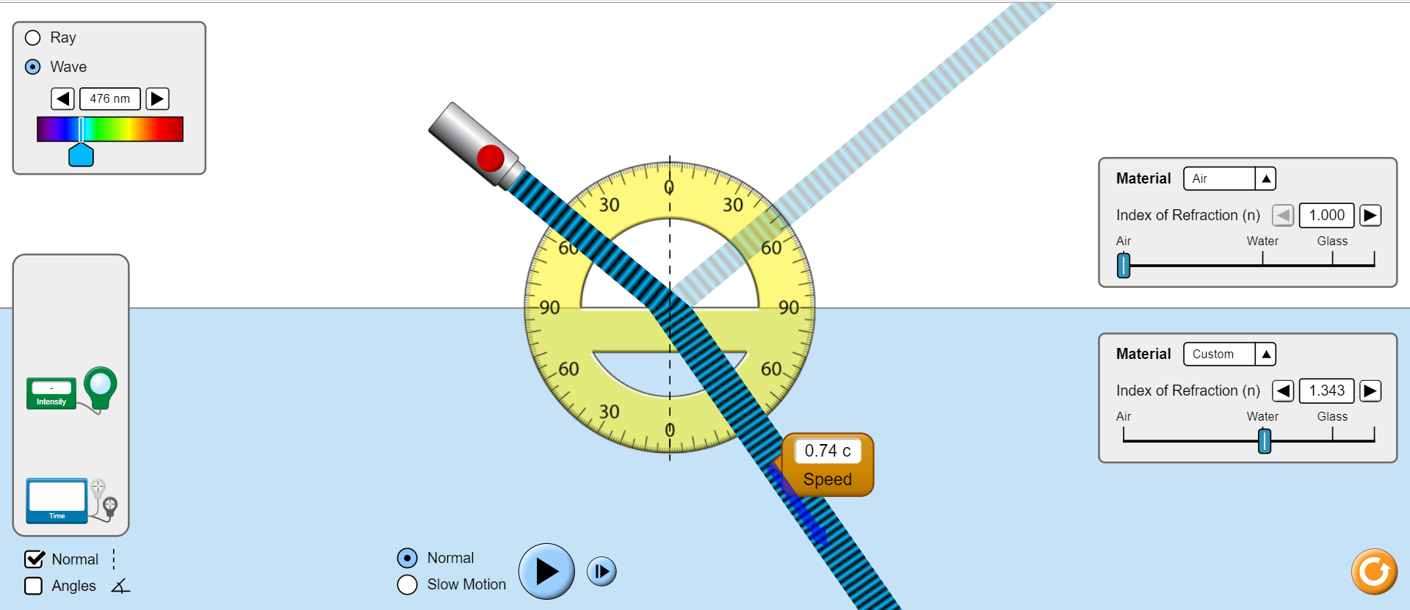

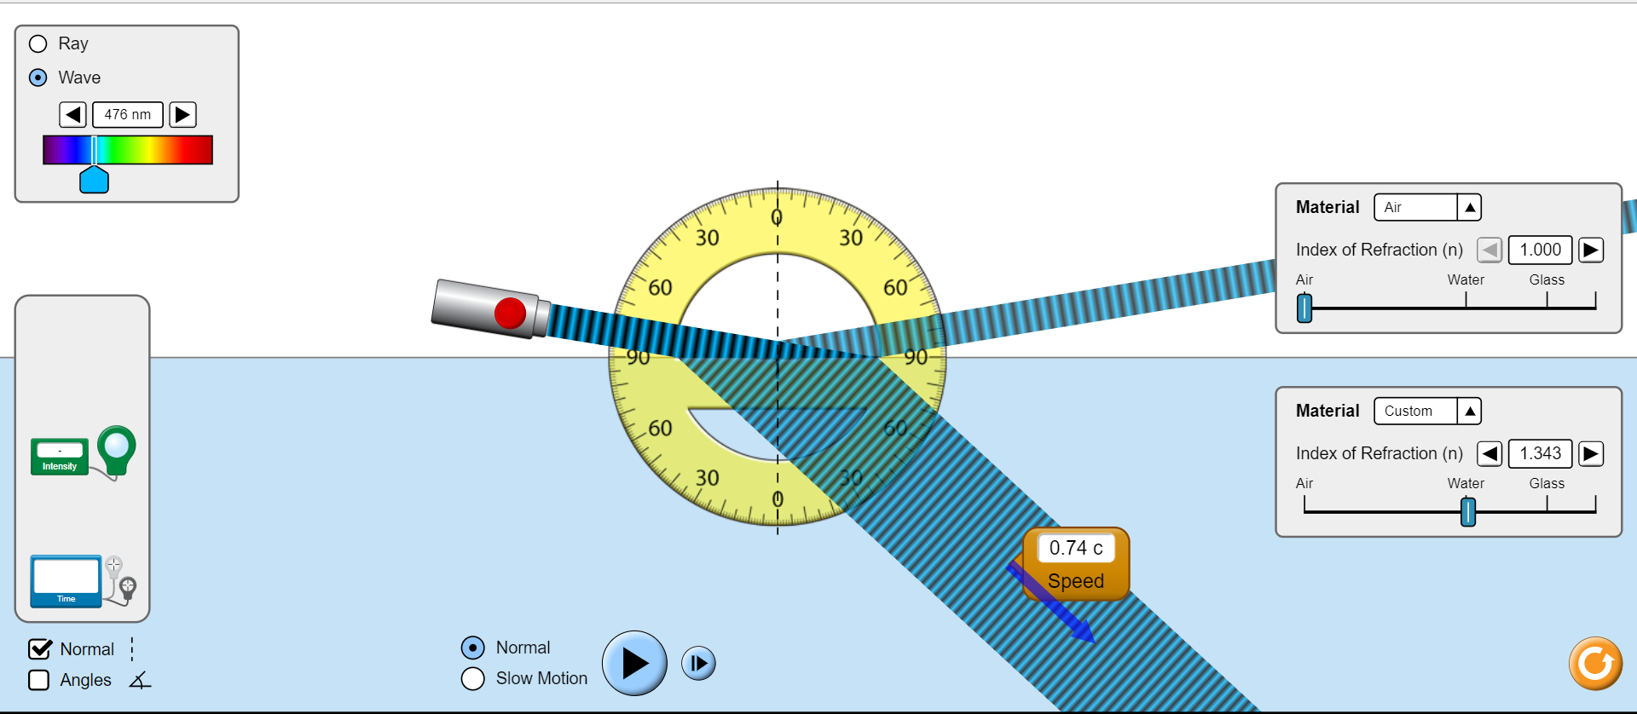

**Conclusion:**

The speed of refracted ray is independent of the angle of incidence.

***PHASE CHANGES IN REFLECTED RAY:***

1. When refractive index of medium 2 is less than that of medium 1

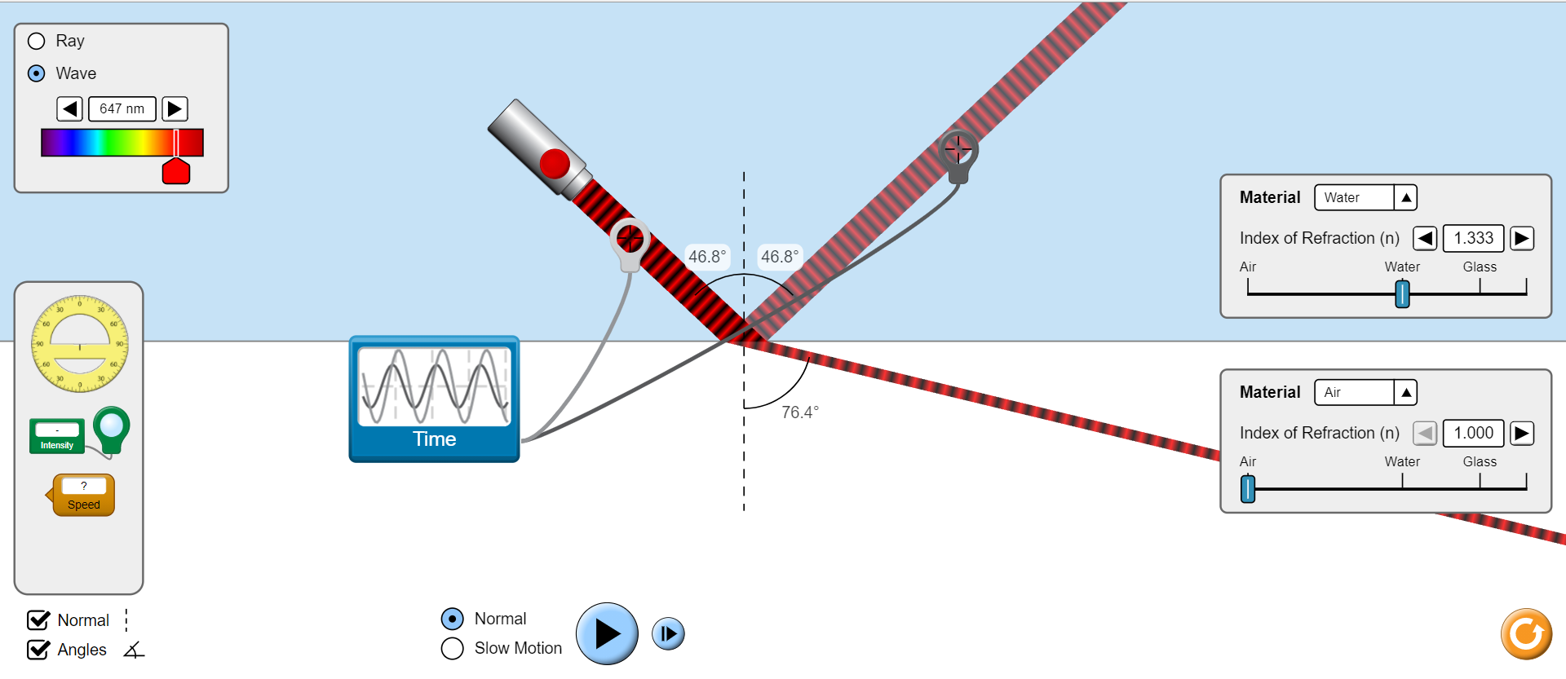

1. When refractive index of medium 2 is more than that of medium 1

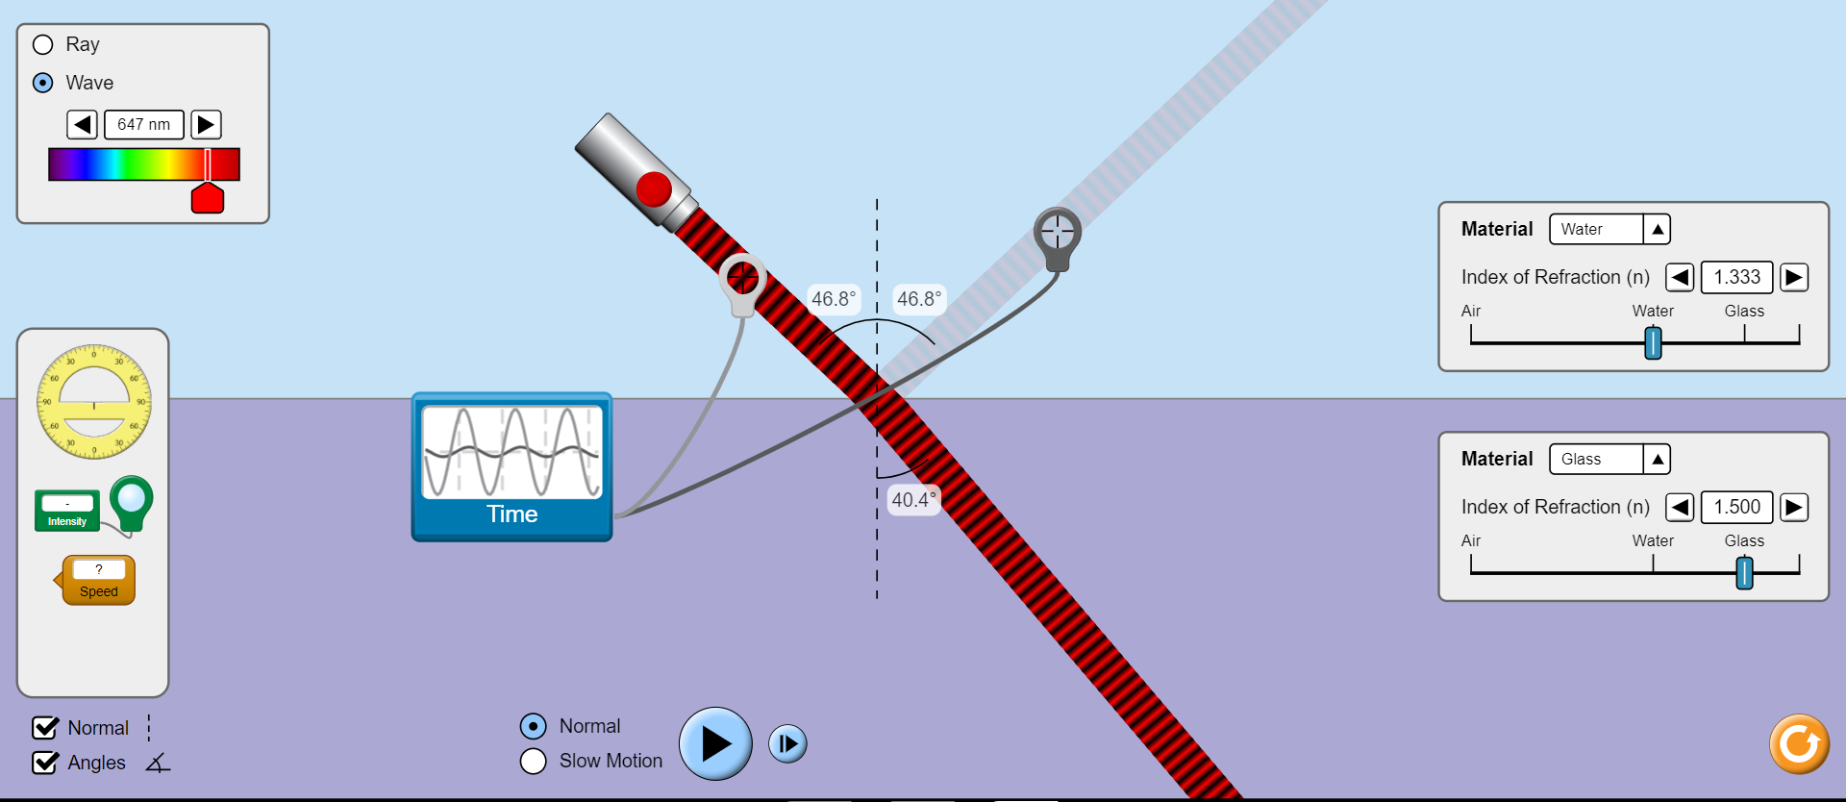

***PHASE CHANGES IN REFRACTED RAY:***

1. When refractive index of medium 2 is less than that of medium 1.

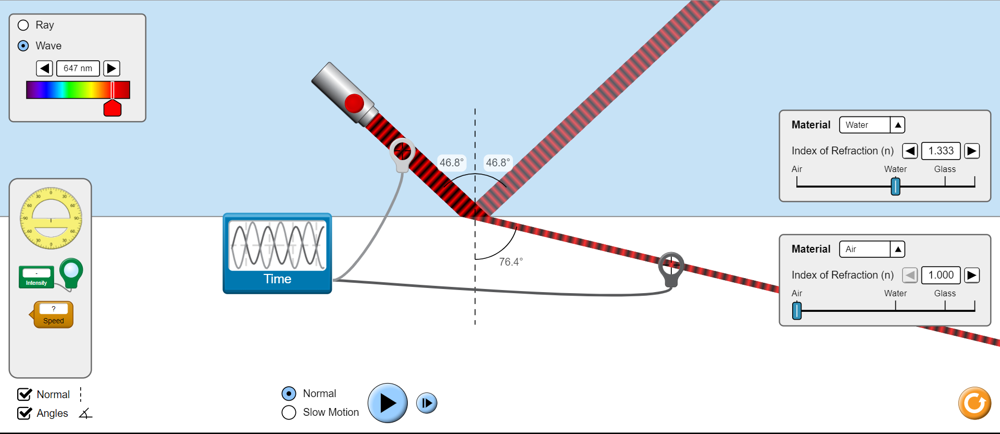

1. When refractive index of medium 2 is more than that of medium 1.

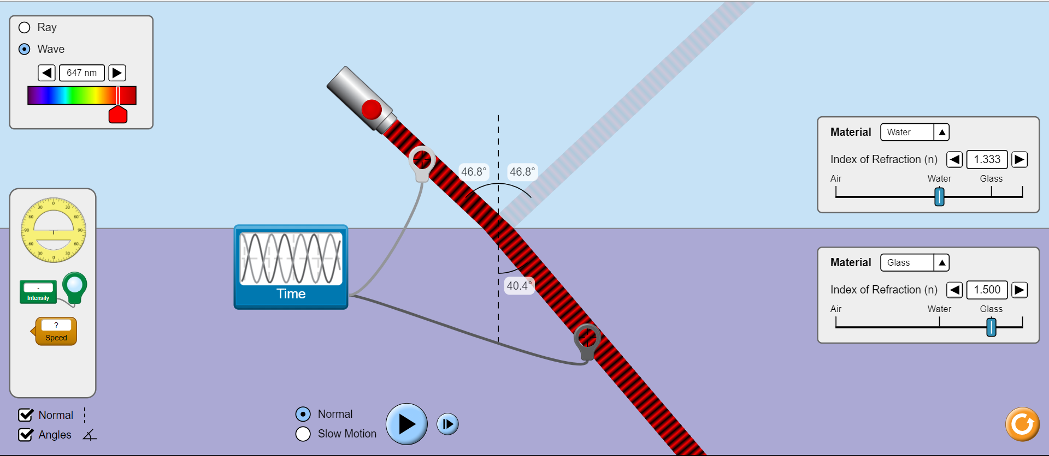

***Error analysis* -:**

Here, the phase change for refracted ray should have been zero in both the cases as we know from theoretical knowledge.

For reflected ray, the phase change should have been zero for case(a) and π for case(b) which is not so.

Our observations do not comply with the theoretical results. This is an error. But this is due to the simulation algorithm and cannot be rectified by us.

***CRITICAL ANGLE***

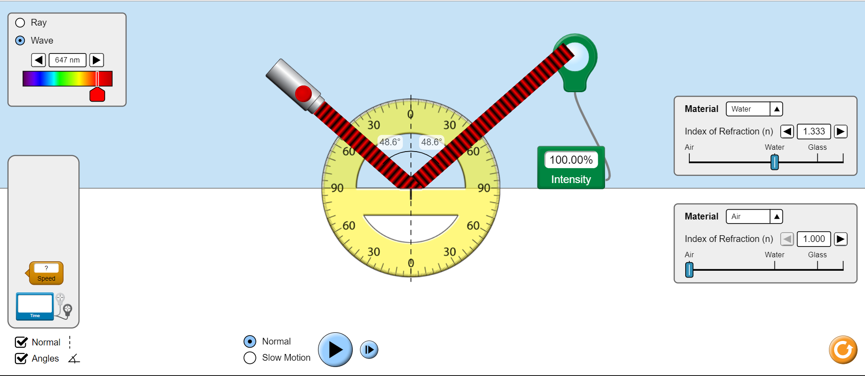

**Conclusion:**

Here, as we see that the intensity of reflected ray is 100% , it shows that no part of incident wave was refracted-all of it was reflected .This is condition of Total Internal Reflection and the critical angle for water-air boundary is 48.6 degree.

***Result* -:**

For simulation 1:

* Strength: Larger the acceleration of the transmitting electron stronger the electromagnetic field strength, that is, larger force vectors.

Direction: It takes some time for the change in this direction of the force to be felt since this change is communicated or propagated out at the speed of light. First the force will be exerted strongly in one direction then this will reverse and the electron will feel a strong force in the opposite direction, and the cycle will continue. The direction of arrows move with direction of electron and both electrons ( source and receiver) are moving in same direction.

* It is evident from this snapshot that when the radiation reaches the antenna on the right, the net force on the receiving electron is zero, and it then moves in the direction of the force, i.e. if the force is directed downwards, the electron will travel downwards as well. Finally, until the electromagnetic waves with the new frequency come, the receiving electron will continue to oscillate at its old frequency.
* If no other parameters are changed, the amplitude of both electrons oscillations remains constant throughout the experiment. However, due to various sorts of channel distortions, the amplitude of the receiving electron oscillation is smaller than that of the source electron, making our signal weak.
* We can see from the snapshots that there is no change in the amplitude though the wavelength has changed a lot which is expected because:- c= λf.
* As the signal goes to the right and receiver, the amplitude decreases, and we can deduce from the snapshot that the ultimate amplitude is lower than the one created from the source. The reason of decreasing amplitude is various types of distortion that occurs in the channel.
* The electron in the receiving antenna feels only the force resulting from the electromagnetic wave at its current location. It only "sees" the transmitting electron because of the effects that the transmitting electron has on the electromagnetic waves. So the receiving electron will keep oscillating at its original frequenc y until the electromagnetic waves with the new frequency arrive. (they move towards the receiving antenna at the speed of light).
* From observations: both wave forms took 6.08 seconds to complete one cycle.

For simulation 2:

* Intensity of refracted wave decreases on increasing the relative refractive index.
* Intensity of refracted wave is independent of frequency of wave.
* Intensity of refracted wave decreases on increasing the angle of incidence.
* The speed of refracted wave is independent of frequency of incident wave.
* The speed of refracted wave decreases on increasing the relative refractive index.
* The speed of refracted wave is independent of the angle of incidence.
* Reflected light will experience a 180 degree phase change when it reflects from a medium of higher [index of refraction](http://hyperphysics.phy-astr.gsu.edu/hbase/geoopt/refr.html#c2) and no phase change when it reflects from a medium of smaller index.
* Refracted ray experiences no phase change in any case.